**Haifan Muhammad Izza**

**122400062**

**TPB 35 Teknik Telekomunikasi**

1. **Program Faktorial**

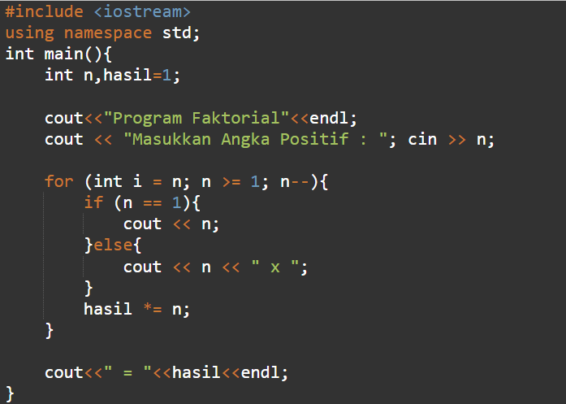

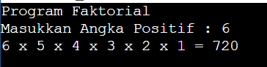

**https://onlinegdb.com/qns3P0a9A**

1. **Segitiga Angka Rata Kanan**

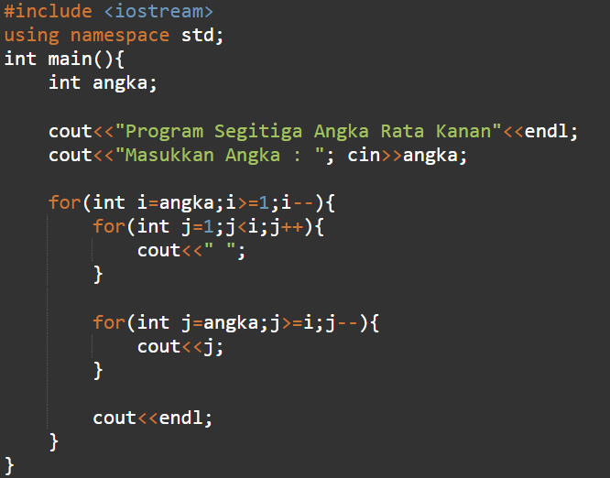

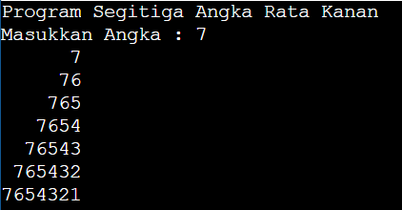

**https://www.onlinegdb.com/roeMe07tt**